Test Plan For Spread Trading Properties Initialization Bug (SEDL#8922)

Session: W_MAIN

Find a Strategy class which has no strategy product defined using HD GUI
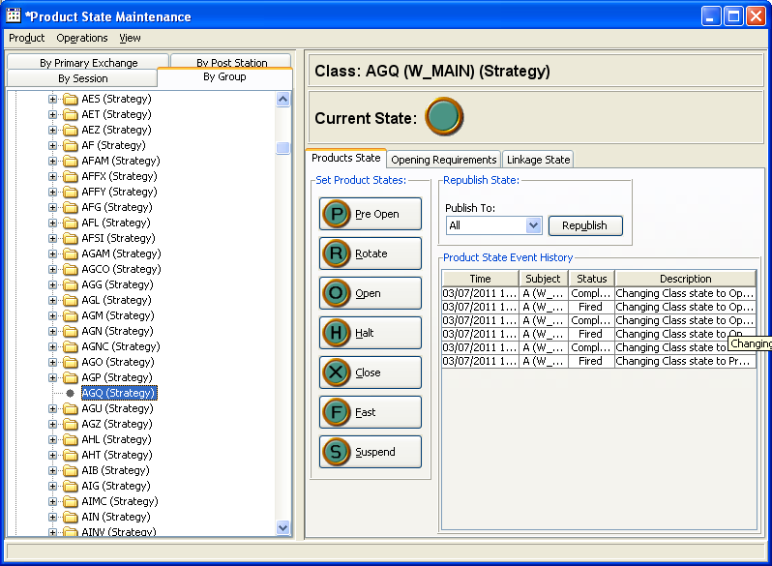

- Create a two leg strategy for this class (first strategy product for this class)
- Enter quotes for Leg1: 1.00 x 100 – 1.20 x 100
- Enter quotes for Leg2: 1.00 x 100 – 1.20 x 100
- Enter a Spread Order for this newly created strategy Defined side 100@MKT
- Verify in the Log after entering the Spread Order no trading properties are initialized in HybridTradeServer.

